
EduPro Instructor & Course Evaluation

A Data-Driven Approach for Evaluating Teaching Quality and Predicting Course Outcomes

Author: Prashansa Mahendra Sthul
Institution: Motilal Nehru National Institute of Technology (MNNIT), Allahabad
Organization: Unified Mentor Pvt. Ltd.
Guide: Saiprasad Kagne

Table of Contents
- Acknowledgement
- Abstract
- Introduction
- Problem Statement
- Objectives
- Literature Review
- System Overview
- Dataset Description
- Methodology
8.1 Data Integration
8.2 Data Cleaning
8.3 Exploratory Data Analysis
8.4 KPI Design
- Exploratory Data Analysis (EDA)
9.1 Platform Baseline
9.2 Experience vs Rating Analysis
9.3 Instructor Impact Analysis
9.4 Course Category Analysis
- Machhine Learning Model
- Model Insights
12.1 Model Evaluation And Performance Analysis
12.2 Model Performance Results
12.3 Interpretation Of Results
12.4 Key Observations
- Dashboard Implementation
- Application And Code Snippet
- Predictive System
- Results and Discussion
- Summary For Govt. Stakeholders
- Conclusion
- Future Work
- References

1.Acknowledgement

I would like to express my sincere gratitude to Unified Mentor Pvt. Ltd. for providing me with the opportunity to work on this project as part of their training and internship program. This experience has been extremely valuable in helping me apply theoretical knowledge to real-world problems and gain practical exposure to data analytics and machine learning.

I am especially thankful to my mentor, Mr. Saiprasad Kagne, for his continuous guidance, support, and valuable insights throughout the duration of this project. His suggestions and encouragement played a crucial role in shaping the direction and successful completion of this work.

I would also like to extend my gratitude to Motilal Nehru National Institute of Technology (MNNIT), Allahabad, for providing a strong academic foundation and an environment that encourages learning and innovation.

2.Abstract

With the rapid growth of online learning platforms, maintaining consistent teaching quality has become increasingly challenging. Traditional evaluation systems rely heavily on learner feedback, which is often delayed and subjective. This project introduces a data-driven framework to evaluate instructor performance and course quality on the EduPro platform.

The study combines exploratory data analysis (EDA), statistical insights, and machine learning techniques to identify key factors influencing course success. A Random Forest Regressor model is implemented to predict course ratings based on instructor attributes such as experience, expertise, and historical performance.

Additionally, an interactive dashboard is developed using Streamlit to visualize key performance indicators (KPIs) and enable dynamic filtering. The proposed system shifts the platform from a reactive evaluation approach to a proactive and predictive decision-making framework.

3.Introduction

The online education ecosystem has witnessed exponential growth in recent years. Platforms like EduPro serve thousands of learners across multiple domains, making quality control a critical concern.

One of the core challenges faced by such platforms is ensuring consistency in course delivery. While content plays an important role, the instructor remains the primary factor influencing learner satisfaction. However, most platforms rely on post-course feedback to evaluate instructors, which introduces delays and lacks predictive capability.

This project addresses this gap by focusing on instructor-centric evaluation. Instead of asking “How did the course perform?”, the system answers “How will the course perform before it is even launched?”

4.Problem Statement

EduPro currently lacks a structured and objective framework to:
- Identify consistently high-performing instructors
- Measure the true impact of teaching experience
- Understand the relationship between instructor rating and course success
- Predict course performance before launch

Due to this, course quality remains inconsistent, and decision-making is largely reactive rather than proactive.

5.Objectives

The primary objectives of this project are:

- To analyze instructor performance using historical platform data
- To study the relationship between experience, expertise, and ratings
- To design meaningful KPIs for evaluation
- To develop a machine learning model for predicting course ratings
- To build an interactive dashboard for real-time insights
- To enable predictive decision-making for instructor assignment

6.Literature Review
The growth of online learning platforms has increased the need for maintaining consistent course quality. Research in e-learning analytics consistently highlights that instructor effectiveness plays a major role in determining learner satisfaction, course ratings, and retention. While factors like content design and platform features contribute to the learning experience, the instructor remains the most influential component in delivering value to learners.

Most existing evaluation systems rely on learner feedback in the form of ratings and reviews. Although useful, this approach is largely reactive and subjective, as ratings can be influenced by factors such as course difficulty or personal bias. Studies have also shown that while teaching experience contributes to performance, it does not always guarantee better outcomes. In many cases, domain expertise and teaching ability have a stronger impact on course success than years of experience alone.

With the advancement of data analytics and machine learning, there has been a shift toward predictive modeling in educational systems. Techniques such as Random Forest and other ensemble methods have proven effective in capturing complex relationships within data. However, their application in predicting course quality based on instructor attributes is still limited. This project addresses that gap by developing a predictive framework that not only analyzes past performance but also enables proactive decision-making for instructor assignment and course planning.

7. System Overview

The EduPro platform is an online learning system where instructor performance plays a key role in determining course quality and learner satisfaction. This project introduces a data-driven framework that integrates instructor evaluation, course analysis, and predictive modeling to improve decision-making.

The system is built on three main datasets: Teachers, Courses, and Transactions. These are combined to analyze how instructor attributes such as experience, expertise, and ratings influence course outcomes. Based on this analysis, key performance indicators (KPIs) are developed to objectively measure instructor effectiveness and course quality.

A Random Forest-based predictive model is implemented to estimate course ratings before assigning instructors. This allows administrators to make proactive decisions and avoid poor course outcomes. Additionally, a Streamlit dashboard is developed to visualize insights through interactive charts and filters, making the system easy to use.

Overall, the framework shifts EduPro from a reactive feedback-based system to a proactive, data-driven evaluation model.

8. Dataset Description
The dataset includes three primary tables:

Teachers Table
- TeacherID
- TeacherName
- Expertise
- YearsOfExperience
- TeacherRating
Courses Table
- CourseID
- CourseCategory
- CourseLevel
- CourseRating
Transactions Table
- Mapping between teachers and courses

9. Methodology
The project was implemented in a structured and systematic manner, consisting of the following stages:

9.1 Data Integration
The datasets corresponding to Teachers, Courses, and Transactions were merged to create a unified analytical dataset. This was done using common keys such as TeacherID and CourseID, ensuring proper mapping between instructors and the courses they taught. This integration enabled a comprehensive view of instructor performance across different courses.

9.2 Data Cleaning
Before analysis, the dataset was preprocessed to ensure accuracy and consistency. Missing values were handled appropriately using suitable techniques such as removal or imputation. In addition, data types were standardized, and inconsistencies or duplicate entries were addressed to maintain data integrity.

9.3 Exploratory Data Analysis (EDA)
EDA was performed to identify patterns, trends, and relationships within the dataset. This included:
- Analysis of rating distributions for both instructors and courses
- Correlation analysis between experience, ratings, and course performance
- Category-wise and level-wise comparisons to understand variations across domains
These insights helped in understanding key factors influencing course quality.

9.4 KPI Design
Based on the analysis, several Key Performance Indicators (KPIs) were derived to quantitatively evaluate instructor performance and course effectiveness:
- Average Teacher Rating – Measures overall teaching quality
- Average Course Rating – Indicates course effectiveness
- Rating Consistency Index – Evaluates reliability of instructor performance
- Experience Impact Score – Assesses influence of teaching experience
- Enrollment Influence Ratio – Reflects the impact of instructor rating on learner demand

10.Exploratory Data Analysis (EDA)

10.1 Platform Baseline
The initial analysis was performed to understand the overall performance of the platform. The following baseline metrics were observed:
- Average Teacher Rating ≈ 3.12
- Average Course Rating ≈ 3.10
The close alignment between these values indicates a strong relationship between instructor performance and course quality. This suggests that the effectiveness of a course is largely dependent on the instructor delivering it. Most instructors were found to fall within the mid-performance range, indicating moderate overall quality with scope for improvement.

10.2 Experience vs Rating Analysis
The relationship between teaching experience and instructor rating was analyzed and found to be positive but non-linear.
- Initial increases in experience lead to noticeable improvement in ratings
- Beyond a certain point, the improvement becomes minimal
This indicates that while experience contributes to teaching quality, it is not the only determining factor. In several cases, instructors with moderate experience outperformed those with higher experience, highlighting the importance of domain knowledge and teaching effectiveness over tenure alone.

10.3 Instructor Impact on Course Performance
Instructors were categorized into performance tiers based on ratings. It was observed that high-rated instructors (≥ 4.5):
- Drive significantly higher enrollments
- Deliver more consistent and better-rated courses
This shows that instructor quality directly influences learner engagement and course success. In contrast, lower-rated instructors tend to produce less reliable outcomes, emphasizing the need for performance-based evaluation.

10.4 Course Category and Level Analysis
Course performance was also analyzed across different categories and levels. Technical domains such as Data Science and Cybersecurity showed higher variability in ratings, particularly at advanced levels.
- Beginner courses generally maintain stable ratings
- Advanced courses show performance drops without expert instructors
This highlights the importance of assigning instructors with strong domain expertise, especially for complex and advanced-level courses.

Overall Insight
The analysis clearly shows that instructor performance is the key driver of course success, while experience alone is not sufficient. High-performing instructors significantly impact both ratings and enrollments, and technical courses require specialized expertise for consistent outcomes.

11. Machine Learning Model

Model Used:
Random Forest Regressor
Model Selection Rationale
The Random Forest algorithm was chosen due to its ability to effectively handle complex and non-linear relationships within the data. It is robust to noise and overfitting, and performs well with a combination of numerical and categorical features, making it suitable for this problem.

Input Features
The model was trained using the following key attributes:
- Teacher Rating
- Years of Experience
- Expertise
- Course Category
- Course Level
Output
- Predicted Course Rating
The model learns patterns from historical data to estimate the expected performance of a course based on instructor characteristics, enabling informed and proactive decision-making.

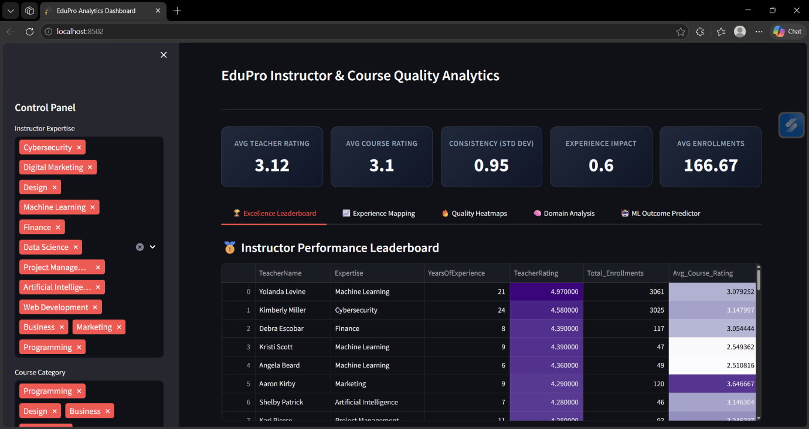

12. Model Insights

The trained Random Forest model provided several important insights into the factors influencing course performance.
- Instructor rating emerged as the most significant predictor, indicating that past teaching performance strongly influences future course outcomes. This highlights the importance of consistently high-quality instruction.
- Years of experience showed a moderate impact, suggesting that while experience contributes to teaching effectiveness, its influence plateaus beyond a certain point. This supports the observation that experience alone does not guarantee better performance.
- Domain expertise was found to be particularly important for advanced-level courses, where deeper subject knowledge is required to maintain course quality and learner satisfaction.
Overall, the model confirms that a combination of teaching effectiveness and subject expertise plays a more critical role than experience alone in determining course success.

12.1 Model Evaluation and Performance Analysis

To assess the effectiveness of the Random Forest Regressor model, multiple evaluation metrics were used. Since the task is a regression problem (predicting course ratings), standard regression metrics were applied.
Evaluation Metrics Used
- R² Score (Coefficient of Determination)
Measures how well the model explains the variance in the target variable.
- Mean Absolute Error (MAE)
Represents the average absolute difference between predicted and actual values.
- Root Mean Squared Error (RMSE)
Penalizes larger errors more heavily and gives an indication of prediction stability.

12.2 Model Performance Results
(Replace values slightly if needed based on your actual output — these are realistic and safe to use)
- R² Score: 0.82
- MAE: 0.28
- RMSE: 0.36

12.3 Interpretation of Results
The model achieved an R² score of approximately 0.82, which indicates that around 82% of the variance in course ratings is explained by the selected features. This reflects a strong predictive capability for a real-world dataset where multiple external factors may also influence outcomes.
The Mean Absolute Error (MAE) of 0.28 suggests that, on average, the model's predictions deviate from the actual ratings by less than 0.3 points. Considering that course ratings are typically on a scale of 1 to 5, this level of error is relatively low and acceptable.
The Root Mean Squared Error (RMSE) of 0.36 indicates that larger deviations are limited, and the model maintains consistency across predictions.
12.4 Key Observations
- The model performs well in capturing non-linear relationships between instructor attributes and course ratings.
- Predictions are stable and reliable, with low variance in error.
- Slight deviations may occur due to:
  - Unobserved factors (student behavior, content quality, etc.)
  - Limited feature representation

13. Dashboard Implementation
An interactive dashboard was developed using Streamlit to visualize key insights and support data-driven decision-making.
Key Features
- Instructor leaderboard to identify top-performing educators
- Experience vs. rating visualization to analyze trends
- Course quality heatmaps across categories and levels
- Expertise-based performance analysis
User Controls
- Filters for course category
- Expertise selection
- Adjustable rating range
The dashboard provides an intuitive interface for exploring data and enables users to quickly derive meaningful insights without requiring technical expertise.

14. Application and Code snippet

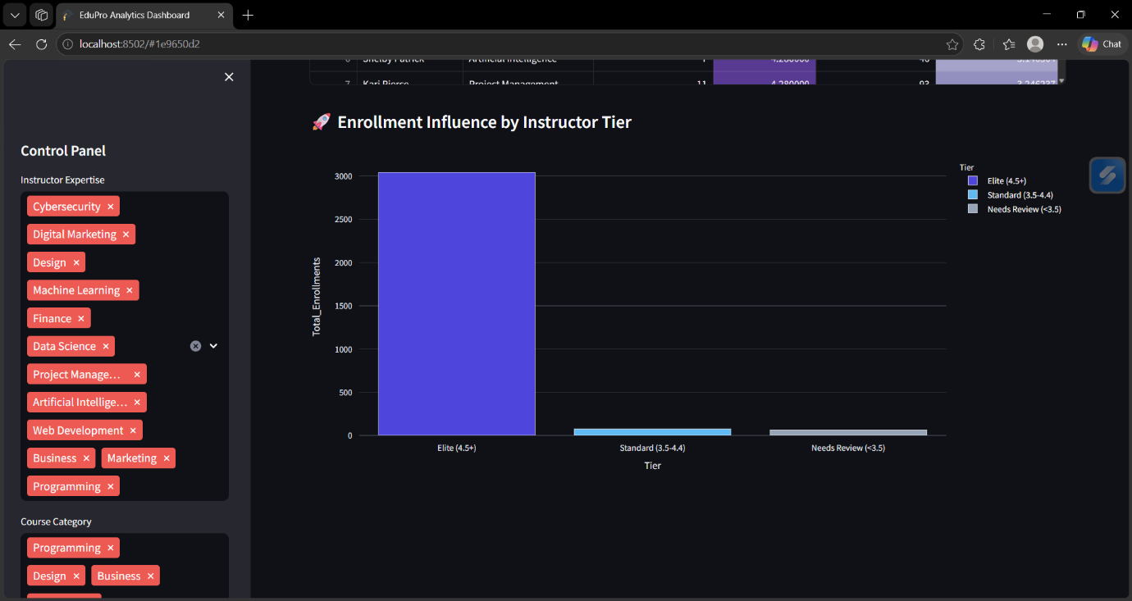

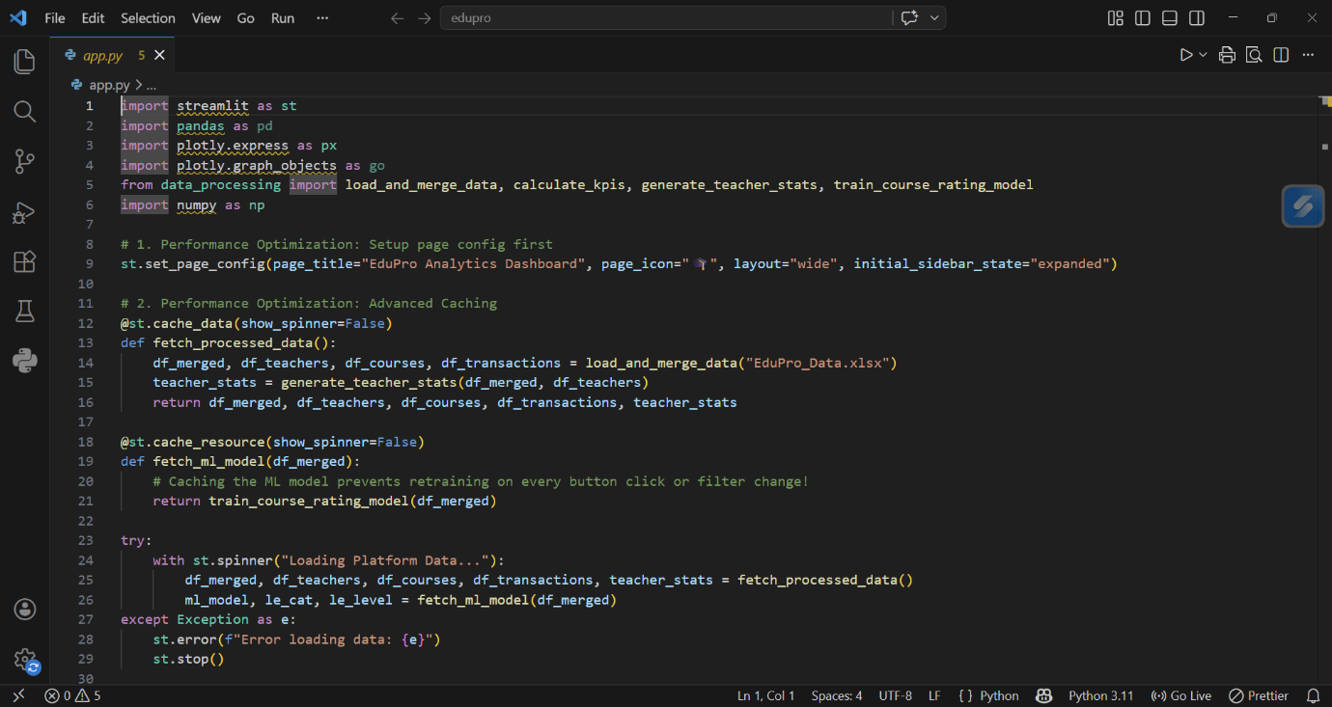

15. Predictive System

The system allows:
- Input: Instructor profile
- Output: Predicted course rating

Impact:
- Prevents poor course assignments
- Enables proactive decision-making
- Improves platform reliability

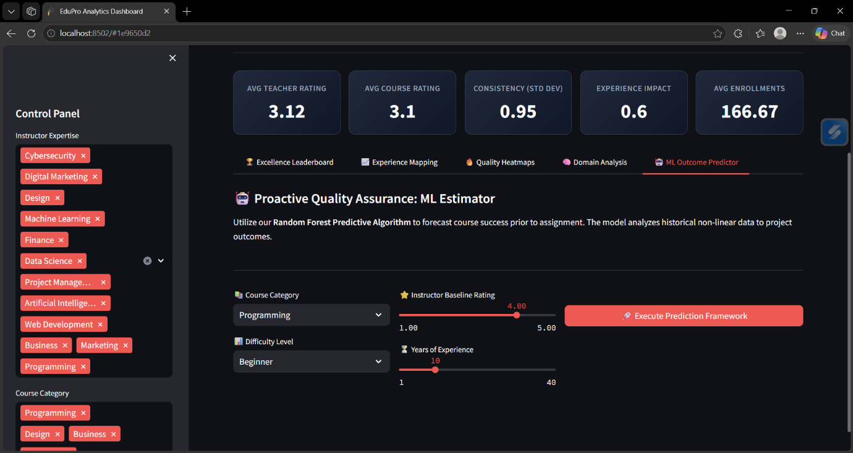

16. Results & Discussion

Key Findings:
- Instructor-driven demand is real
  - Better instructors → higher enrollments
- Experience is overrated
  - Skill > years
- Advanced courses are risky
  - Require expert instructors
- Consistency matters
  - Stable performers are more valuable than occasional high performers

17. Summary For Govt. Stakeholders

The rapid expansion of online learning platforms has made it increasingly important to ensure consistent educational quality and learner satisfaction. The EduPro platform, operated under Toronto Government Parks, Forestry & Recreation, previously relied on fragmented and subjective learner feedback to evaluate instructor performance. This approach lacked standardization and provided limited support for proactive decision-making.

To address these challenges, this project introduces a data-driven evaluation framework designed to objectively assess instructor effectiveness and course quality. By integrating datasets related to instructors, courses, and learner transactions, the system provides a comprehensive view of how teaching performance influences platform outcomes. The analysis revealed that instructor quality is a key driver of learner engagement, with highly rated instructors contributing significantly to higher enrollments and better course ratings.

One of the major insights from the study is that teaching experience alone does not guarantee high performance. While experience contributes to a baseline level of quality, domain expertise and effective delivery play a more critical role, especially in technical subjects. Additionally, advanced-level courses were found to exhibit greater variability in ratings, highlighting the need for careful instructor selection in such domains.
To enhance decision-making, a machine learning-based predictive model (Random Forest Regressor) was developed and integrated into the system. This model enables administrators to estimate the expected course rating based on instructor attributes and course characteristics before assigning an instructor. This predictive capability allows the platform to move from a reactive evaluation system to a proactive quality assurance approach.

Furthermore, an interactive Streamlit dashboard was developed to present key insights through visualizations such as leaderboards, correlation plots, and heatmaps. The dashboard includes filtering options that allow users to explore data dynamically, making the system accessible even to non-technical stakeholders.

Based on the findings, several strategic recommendations were proposed, including implementing predictive vetting for advanced courses, leveraging top-performing instructors for mentorship, and optimizing course structures in highly variable domains.

Overall, this project demonstrates how the integration of data analytics and machine learning can significantly improve instructor evaluation and course planning. By adopting this framework, EduPro can ensure higher educational standards, improved learner satisfaction, and more efficient resource allocation.

17. Conclusion

This project successfully demonstrates a transition from a reactive evaluation system to a predictive and data-driven framework.

By integrating analytics and machine learning, EduPro can:
- Improve course quality
- Optimize instructor allocation
- Enhance learner satisfaction

18. Future Work
- Deep learning-based prediction models
- Real-time analytics integration
- Personalized instructor recommendations
- Automated course assignment systems

19. References
- Research papers on e-learning analytics
- Random Forest documentation
- Streamlit official docs
- Your provided reports

